**DAILY ONLINE ACTIVITIES SUMMARY**

|  |  |  |  |  |  |
| --- | --- | --- | --- | --- | --- |
| **Date:** | **11-06-2020** | | **Name:** | **Shanbhag Atish Manoj** | |
| **Sem & Sec** | **6th - B** | | **USN:** | **4AL17CS085** | |
| **Online Test Summary** | | | | | |
| **Subject** | **PAP Assignment Test-3** | | | | |
| **Max Score** | **30** | **Score** | | **29** | |
| **Certification Course Summary** | | | | | |
| **Course** | **Android App development** | | | | |
| **Certificate Provider** | **Udemy** | **Duration** | | | **15hours** |
| **Coding Challenges** | | | | | |
|  | | | | | |
| **Status: executed** | | | | | |
| **Uploaded the report in GitHub** | | **Yes** | | | |
| **If yes Repository name** | | <https://github.com/atish-shanbhag/Updates> | | | |
| **Uploaded the report in slack** | | **Yes** | | | |

PAP assignment -3

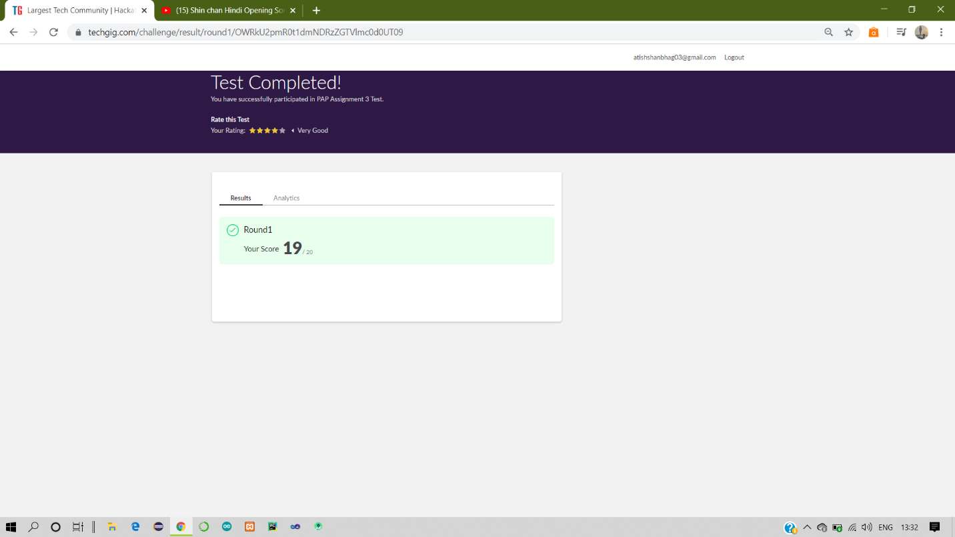

Certification Course Details:

Report-

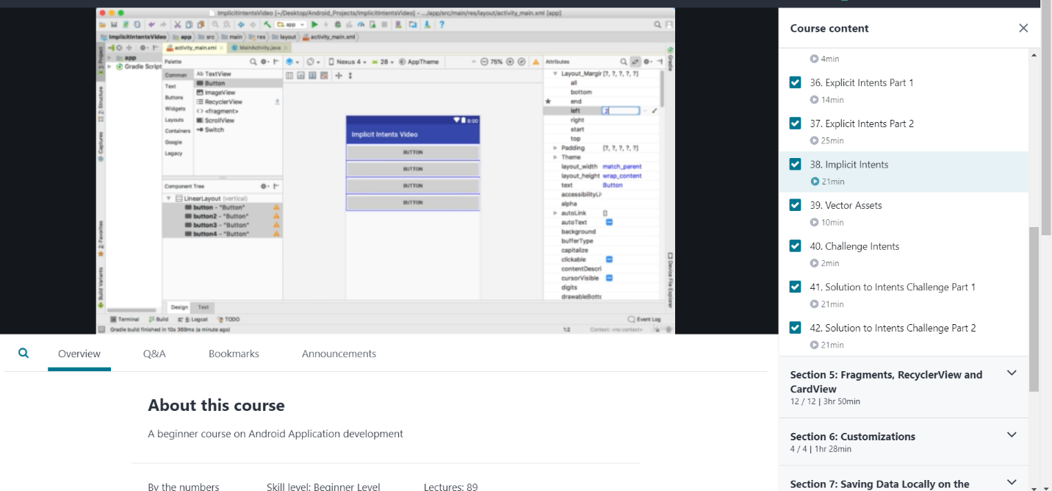

In todays session of online certification, of android application I have studied regarding intents with implicit, vector and challenge, and also its implementation.

Coding Challenges Details:

The below GitHub link for details

<https://github.com/atish-shanbhag/Updates>

P-1-Java program to find the nodes which are at the maximum distance in a Binary Tree

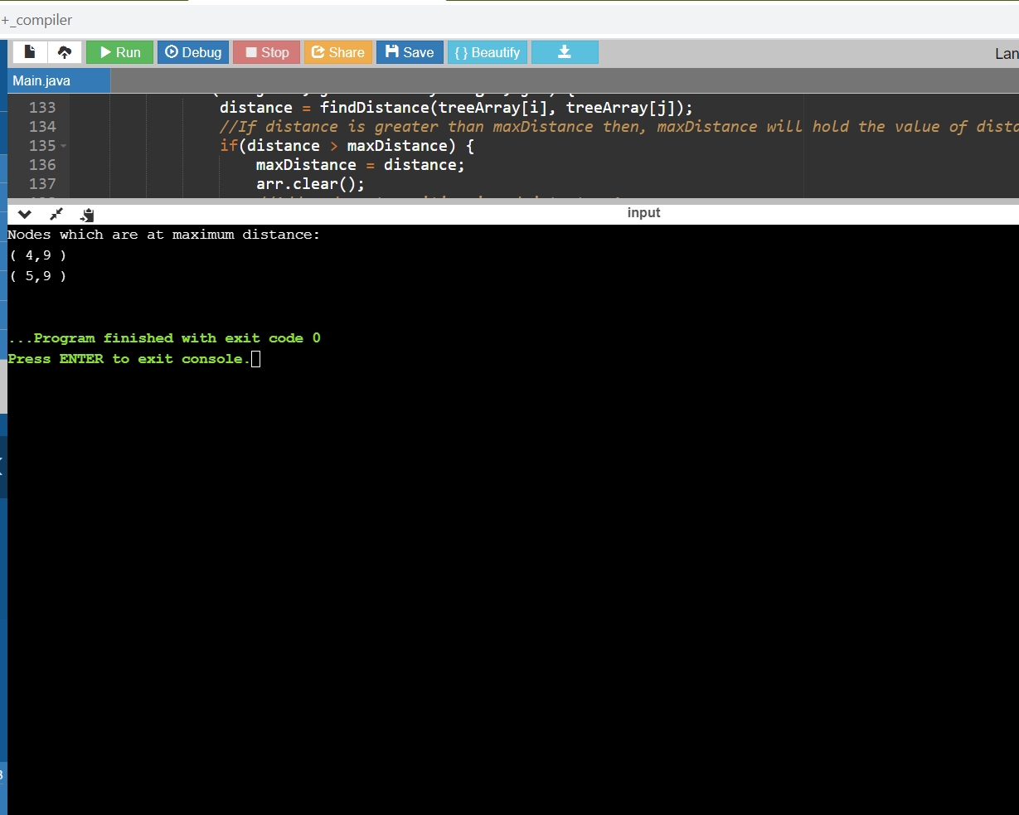

**P-2-**Python Program to Convert a string to all uppercase if it contains at least 2 uppercase characters in the first 4 characters

